
FOOTBALL NETBALL
EAST GIPPSLAND INC.

ABN 21 232 768 523 A0052434R
45 Gatehouse Drive, Eastwood, Vic 3875

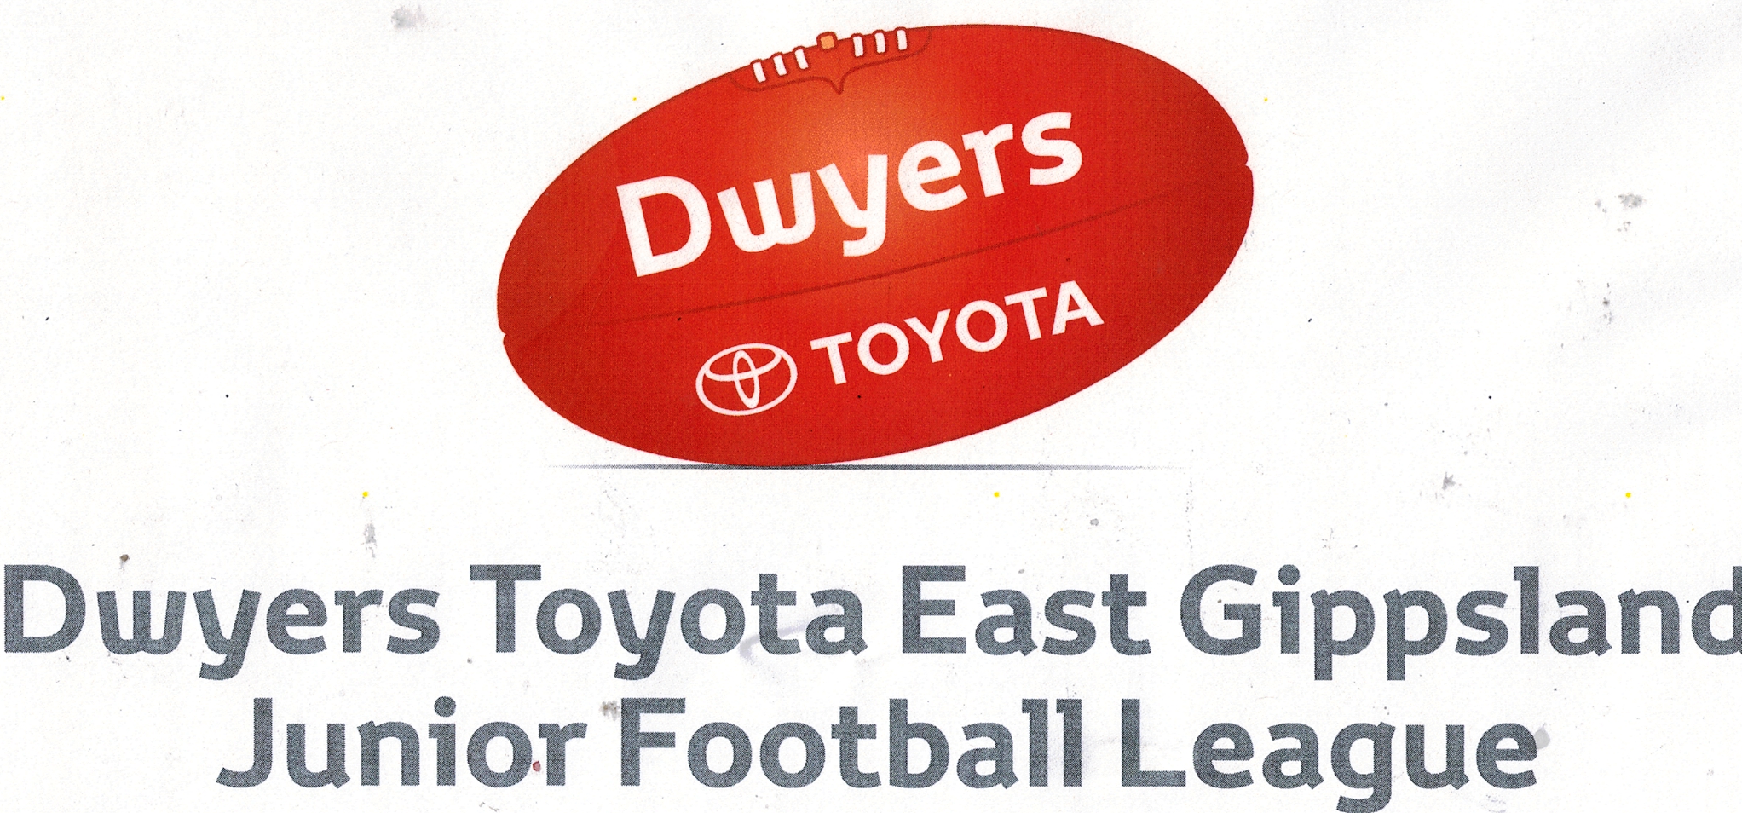
EGJFA NOTICE OF CHARGE
Date: ___/____/2025
To: ________________________________________________________________
This Notice of Charge serves to inform you:
- That the named person below (the ‘Charged Person’) has been charged with a Reportable Offence as defined under the Laws of Australian Football;
- Of the details of the Reportable Offence;
- Of the grading of, and sanction applicable to, that Reportable Offence; and
- Of the options available to the Charged Person, including submission of an Early Guilty Plea or contesting the charge at the Tribunal.

(a) Reportable Offence details

Charged Person

Charged Person’s Club

Match date

Grade

Match between

Time of Offence

Law reported under

Offence Details

(b) Reportable Offence grading

The Match Review Panel has graded the Reportable Offence as follows:

Conduct

Impact

Contact

OR

Reportable Offence referable directly to the Tribunal for determination without grading.

(c) Prescribed penalty [delete if not applicable]

In accordance with AFL Vic Country Rules, based on the grading above, the prescribed Base Sanction for the Reportable Offence is a ____________________________________________ (e.g. two match suspension]. However, with submission of an Early Guilty Plea, the Charged Person can accept an Early Guilty Plea penalty of a
____________________________________________ [e.g. one match suspension].

[OR]

In accordance with AFL Vic Country Rules, based on the grading above, the Reportable Offence will be referred directly to the Tribunal for determination.

(d) Decision on Early Guilty Plea penalty [delete if not applicable]

Please confirm in writing by no later than 5:00pm on ___/___/2025

1. If you accept the Early Guilty Plea penalty; or
2. If you propose to contest the Reportable Offence at the Tribunal.

(e) Contesting the matter at Tribunal

If the matter is to proceed to Tribunal, the Person/Club will shortly be advised of the time, date and location of the Tribunal hearing.

If you have any questions in relation to this Notice, please contact the undersigned.

Regards

Rod Twining
0407347727
egfl2004@bigpond.net.au

